Welcome to another wonderful year of faith formation! Our High School Faith Formation program will focus on a balance between understanding the catechism, building meaningful relationships, and living out the mission of God and our Church! We will meet weekly on most Wednesday from 7:00 PM – 8:30 PM! Our program utilizes both large & small group settings, allowing for discussion, reflection, prayer, talks, and other activities! In addition to our usual sessions, students will have expectations & opportunities to participate in Youth Masses, Youth Ministry Events, & other Parish events! Our parish mission statement is "Bearing witness to Christ in both word & deed," and our program strives to achieve just that!

OFFICE HOURS & CONTACT INFORMATION
These are set hours that I will be available and in my office!
Monday, Tuesday, Thursday, Friday – 10:30 AM – 4:00 PM
Wednesday – 12:30 PM – 8:30 PM
*ALWAYS AVAILABLE BY APPOINTMENT*
If these hours don’t work for you, please contact me to set up a different time to meet! I am very flexible and will work with you to make something work!
The best way to reach me is via email at ff-youth@stbrons.com. You can also call my office phone at 715-341-6700 x4214, but I might not receive your message as quickly. If you ever have any questions or concerns, please contact me!

SESSIONS
Wednesdays at 7:00 PM – 8:30 PM
Mary Room – St. Bronislava Parish

CURRICULUM
During the first two years of the Confirmation Program (9-10), students will be attending weekly Wednesday evening Faith Formation sessions, which will engage them with Life Teen's Confirmation Curriculum, "Purpose." Purpose looks to answer three big questions: (1) Why God? (2) Why Jesus? (3) Why the Church? It encourages teens to dive deeper into their faith & rediscover what being a confirmed member of the Catholic faith truly means.

SESSION ATTENDANCE
Your student is expected to attend every session that he/she is physically able to. Obviously, things might come up (ie: illness, vacations, tournaments, etc.) in which your student won’t be able to make it on a Sunday – that is OKAY. Life happens! I just ask that you keep an open line of communication with me as to what is going on and why they can’t make class. This way I can better understand the situation and can better serve you and your family, rather than just mark your student absent with no context and no way to help if need be.
If your student is continually absent from class or misses more than THREE sessions, I will be contacting you to discuss your child’s attendance. There is a certain number of hours of catechesis that is required by the diocese each school year for a student to be eligible for Confirmation when they reach their junior year. If your student does not meet these expectations, it might prevent them from receiving the Sacrament when they are ready.
If your student misses class, they are expected to make-up class materials at home. After each session, you will receive an email with activities, videos, songs, reflections, and other materials covered during class. It is expected that you and your student go through this material together so that way they don’t miss any content (because it all is important!).

MASS ATTENDANCE & JOURNALS
For all intents and purposes, students are expected to attend Mass each weekend. The where or when doesn’t necessarily matter – it is the WHO and the WHAT; and that is Jesus Christ present in the Eucharist. The bottom-line is, the Eucharist is the source and summit of our faith and going to Mass is essential to receiving the gifts only God can give and growing in deeper communion with God. Regardless of whether you attend Mass every Sunday at 8:00 AM at St. Bronislava, or if you travel to neighboring parishes from weekend to weekend to find a celebration that is flexible with your schedule, the intention and expectation is that you make Mass a priority in your family faith life.
Just like last year, students will be expected to fill out their personal Mass Journal after every Mass they attend. In the Mass Journal, the expectation is for students to simply reflect on the question:
“What did God say to me in Mass today?”
That’s it! Students are expected to make a minimum of 20 Mass Journal entries throughout the course of the school year. This isn’t supposed to be an “extra assignment,” rather a way for you to be more intentional & get more out of the Mass.

INVOLVMENT EXPERIENCES
Each student (grades 7-10) is expected to participate in THREE Involvement Experiences each year they are in the program. Involvement Experiences are DIFFERENT than service hours. All too often, students find themselves COUNTING HOURS rather than ENGAGING in ENCOUNTERS with others and Christ. The idea behind Involvement Experiences is that the activities and service projects that you participate in throughout the parish and the community, will lead you closer to God and His disciples.
After each experience, students are expected to complete & submit a Reflection Form (Google Form) which is linked on our website! An Involvement Opportunity is only recorded when a reflection is submitted! Involvement Hours will be tracked via Google Forms! You can find a link to submit these on our website – just fill out the form and your experience will be logged!
A calendar that outlines these opportunities, as well as sign-ups for them are on our website’s “Involvement Experiences” page. If your student does something outside of these opportunities that you would like to apply to their Involvement Hour requirement, please email me with the activity details and a decision will be made on a case-by-case basis.

YOUTH MASSES & YOUTH MINISTRY
Once a month, St. Brons will be holding a Youth Mass, followed by a Youth Ministry event! The Youth Masses are Masses led by our teens for our teens – students will be performing the liturgy roles, leading music, & attending in volume! After each Youth Mass, there will be a fun, yet faith-centered Youth Ministry event for any and all teens to join in on! Each student is expected to participate in ONE Youth Mass and ONE Youth Ministry Event! You can come to all of them if you’d like (that would be AWESOME!) but are required to attend at least one! See the schedule of these below & look on our website to sign-up for Mass or RSVP for the event!
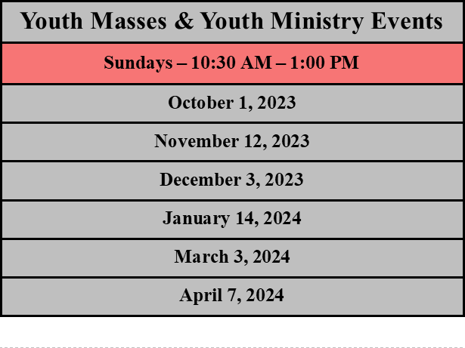

PARENT INVOLVEMENT
As you are encouraging your students to learn about and strengthen their faith, it is crucial to walk with them and support them on this journey! You, as parents, made the decision to raise your child in this beautiful faith, and it is important that you are just as invested in this faith journey as they are! Here are a few ways you can do to support your student as they go through faith formation!
- TALK ABOUT IT AT HOME! Ask your students questions about what they’ve learned each Wednesday and continue conversation about the faith outside the walls of the church. After each session, you will receive an email with activities, videos, songs, reflections, and other materials covered during class; use these materials as springboards for conversation
- GO TO MASS WITH YOUR STUDENT! – Be a living example of the faith for your young people and show them the importance of going to Mass by taking time out of your busy schedule to honor the Holy Sabbath.
- ATTEND PARENT SESSIONS! Beginning later in the year, we will be offering a bible study for our high school parents that runs concurrent with their student’s formation. There will be a handful of sessions that dive deeper into the Eucharist & how we can encounter Jesus’ Real Prescence. All parents are invited and highly encouraged to attend, as they will be great learning opportunities & an awesome springboard to help bring your faith home as a family!
- VOLUNTEER! Fill out our “Volunteer Wishlist” form denoting the different ways in which you are willing to share your God-given gifts with our program! From helping chaperone excursions, to cooking food for events, to subbing for small groups, we need all kinds of help to make this program the best that it can be for your student!
- STAY UP TO DATE ON OUR SOCIALS/WEBSITE! New opportunities and events will always be arising, which are followed up with announcements, sign-ups, and registrations. Check our parish website regularly for updates on our programs and follow us on social media to stay in the loop and get extra faith content!

HANDLE WITH CARE!
Though God is good all of the time, I understand that not every day is a good day, especially when it comes to working with teenagers. We want to do what we can to support your child and make their Faith Formation experience the best that it can be! If your student is experiencing difficulties or is coming to church after a rough morning, day, or week, please email me “Handle with Care.” Nothing else will be said or asked. This will let our team know that your child may need a little extra time, patience, help, and prayers during our time together.

